D. CROSSWORDS:-

ACROSS

1. AR is rel ated to more general concept called mediated reality.

2. With the help of VRD technology, a display is scanned directly on the retina of a viewer’s eye.

3. Speech recognition system technique that translate a user’s spoken words into computer instructions.

4. Many computer vision methods of AR are inherited from visual odometry.

5. AR technology has helped disabled individuals create art by using eye tracking to translate a user’s eye movements into drawings ona screen.

DOWN

6. virtual reality replaces the real world with a stimulated one.

7. adding computer vision and object recognition the information about the surrounding real world of the user becomes interactive and digitally manipulable.

8. MEMS sensors such as accelerometer, GPS and solid state compass make suitable AR platform.

9. a HMD is a display device paired to a headset such as a harness or helmet.

10. devices that can augment only part of ones field like google glass is are intended for an AR experience.

|  |  |  |  |  |  |  |  |  |  |  |  |  |  |  |  |  |  |  |  |
| --- | --- | --- | --- | --- | --- | --- | --- | --- | --- | --- | --- | --- | --- | --- | --- | --- | --- | --- | --- |
|  |  |  |  |  |  |  |  |  |  |  |  |  |  |  |  |  |  |  |  |
|  |  |  |  |  |  |  |  | 7c |  |  |  |  |  |  |  |  |  |  |  |
|  |  |  |  |  |  |  |  | o |  |  |  |  |  |  |  |  |  |  |  |
|  |  |  |  |  |  |  |  | m |  |  |  |  |  |  |  |  |  | 2r |  |
|  |  |  |  |  |  |  |  | p |  |  |  |  |  |  |  |  |  | e |  |
|  |  |  |  |  |  |  | 6v | u |  |  |  |  |  |  |  |  |  | t |  |
|  |  |  |  |  |  |  | i | t |  |  |  |  |  |  |  |  |  | i |  |
|  |  |  |  |  |  | 10g | r | 5e | y | e |  | t | r | a | c | k | i | n | g |
|  |  |  |  |  |  | o | t | r |  |  |  |  |  |  |  |  |  | a |  |
|  |  |  |  |  |  | o | u |  |  |  |  |  |  |  |  |  |  |  |  |
|  |  |  |  |  |  | g | a | v |  |  |  |  |  |  |  |  |  |  |  |
|  |  |  |  |  |  | l | l | i |  | 8m | 1m | e | d | i | a | t | e | d |  |
|  |  |  |  |  |  | e |  | 3s | p | e | e | c | 9h |  |  |  |  |  |  |
|  |  |  |  |  |  |  | r | i |  | m |  |  | m |  |  |  |  |  |  |
|  |  |  |  |  |  | g | e | o |  | s |  |  | d |  |  |  |  |  |  |
|  |  |  |  |  |  | l | a | n |  |  |  |  |  |  |  |  |  |  |  |
|  |  | 4v | i | s | u | a | l |  | o | d | o | m | e | t | r | y |  |  |  |
|  |  |  |  |  |  | s | i |  |  |  |  |  |  |  |  |  |  |  |  |
|  |  |  |  |  |  | s | t |  |  |  |  |  |  |  |  |  |  |  |  |
|  |  |  |  |  |  |  | y |  |  |  |  |  |  |  |  |  |  |  |  |

B. FILL IN THE BLANKS:-

1. Augmented reality allows technologies …………….. while retaining the essential components of AR. (Head Mounted Display)

2. ………………… technologies completely immerse a user inside a synthetic environment. (Virtual Reality)

3. Two ways to accomplish augmentation reality: ……………… or video technologies. (optical)

4. AR system places a premium on …………….., especially the ability to walk around outdoors, away from controlled environments. (portability)

5. AR is a specific example of …………………., using computer as a tool to make a task easier for human to perform. (intelligence amplification)

C. MATCH THE FOLLOWING:-

1. NAVIGATION (a) [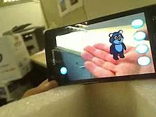](http://en.wikipedia.org/wiki/File:AR_EdiBear0001390_1.jpg)

2. EDUCATION (b)[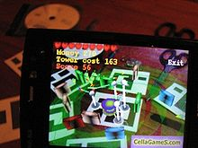](http://en.wikipedia.org/wiki/File:Image-AR_TD0.jpg)

3. MAP OVERLAYS (c) [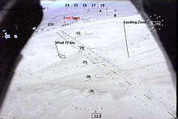](http://en.wikipedia.org/wiki/File:X38_landing_display_from_LandForm_Hybrid_Synthetic_Vision_system..jpg)

4. GAMING (d) [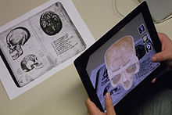](http://en.wikipedia.org/wiki/File:App_iSkull,_an_augmented_human_skull.jpg)

5. MARKER LESS TRACKER (e) [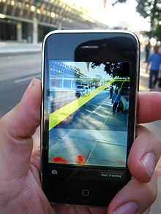](http://en.wikipedia.org/wiki/File:MediatedReality_on_iPhone2009_07_13_21_33_39.jpg)